**Notice of initiation of investigations: Steel Strapping (SS 2025 IN)**

*Ottawa, May 12, 2025*

The Canada Border Services Agency (CBSA) initiated investigations on May 12, 2025, under the Special Import Measures Act, respecting the alleged injurious dumping of steel strapping originating in or exported from the People’s Republic of China (China), the Republic of Korea, the Republic of Türkiye and the Socialist Republic of Vietnam, and the alleged injurious subsidizing of steel strapping originating in or exported from China. The investigations follow a complaint filed by JEM Strapping Systems Inc.

The subject goods are usually imported under the following tariff classification numbers:

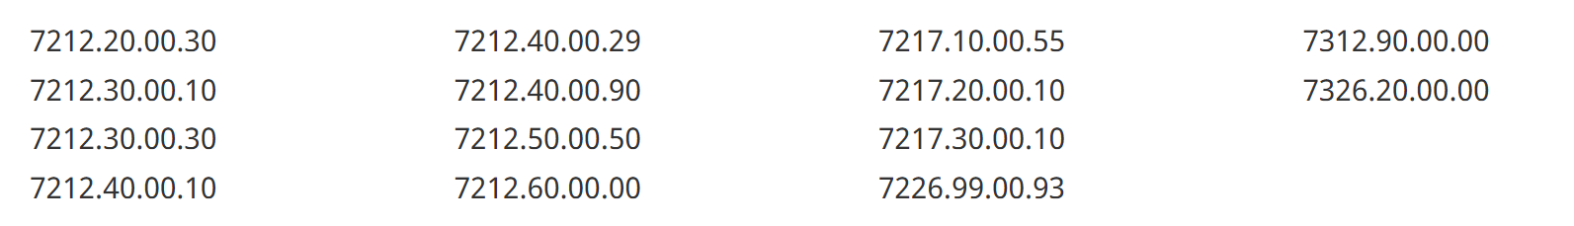

These tariff classification numbers may include non-subject goods, and subject goods may also fall under additional tariff classification numbers.

The product definition is contained in Appendix 1.

The CBSA will investigate whether the imports are being dumped and/or subsidized; and will make a preliminary decision within 90 days, at which time provisional duties may apply.

Additional information about the investigations will be provided in a Statement of Reasons that will be accessible within 15 days.

**Contact us**

Email: [simaregistry-depotlmsi@cbsa-asfc.gc.ca](mailto:simaregistry-depotlmsi@cbsa-asfc.gc.ca)

**Appendix 1: Product definition**

The subject goods are defined as:

Steel strapping, of carbon or alloy steel, with or without seals, whether or not in coils, whether or not punched, whether or not waxed, regardless of surface finish (including whether or not coated, painted, galvanized or “blued”), with a nominal width of 9.5 mm (3/8”) to 50.8 mm (2”) inclusive, and a nominal thickness of 0.38 mm (0.015”) to 1.12 mm (0.044") inclusive (with all dimensions being plus or minus allowable tolerances), originating in or exported from the People’s Republic of China, the Republic of Türkiye, the Republic of Korea, and the Socialist Republic of Vietnam.

Source: <https://www.cbsa-asfc.gc.ca/sima-lmsi/i-e/ss2025/ss2025-ni-eng.html>